ABDUL AKRAM A

720721115002

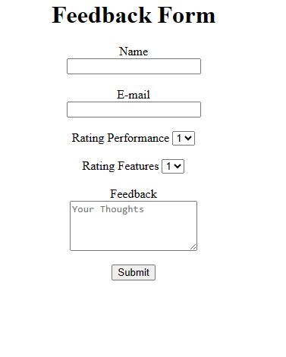 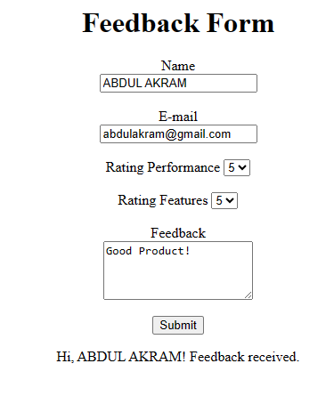

**CODE**

<html>

<head>

    <title>Feedback</title>

</head>

<body>

    <center>

        <h1>Feedback Form</h1>

        <form name="myform">

            Name<center><input type="text" class="textbox1" id="N1"></center><br>

            E-mail<center><input type="email" class="E1" id="E1"></center><br>

            Rating Performance <select name="performance" id="sbox1">

                <option value="rating1">1</option>

                <option value="rating2">2</option>

                <option value="rating3">3</option>

                <option value="rating4">4</option>

                <option value="rating5">5</option>

            </select><br><br>

            Rating Features <select name="features" id="sbox2">

                <option value="rating1">1</option>

                <option value="rating2">2</option>

                <option value="rating3">3</option>

                <option value="rating4">4</option>

                <option value="rating5">5</option>

            </select><br><br>

            Feedback<center><textarea id="fe1" name="feedback" rows="4" columns="50" placeholder="Your Thoughts"></textarea></center><br>

            <button type="button" onclick="submitForm()">Submit</button>

        </form>

    </center>

    <center><div id="outputContainer"></div></center>

    <script>

        function submitForm() {

            var nameInput = document.getElementById("N1").value;

            var emailInput = document.getElementById("E1").value;

            var feedbackInput = document.getElementById("fe1").value;

            var outputContainer = document.getElementById("outputContainer");

            // Check if all input fields are filled

            if (nameInput && emailInput && feedbackInput) {

                outputContainer.innerHTML = "Hi, " + nameInput + "! Feedback received.";

                // Additional code or actions can be added here

            } else {

                outputContainer.innerHTML = "Please fill in all the required fields.";

            }

        }

    </script>

</body>

</html>